Problem 15（易）
Fibonacci number system

The sequence of Fibonacci numbers is defined by
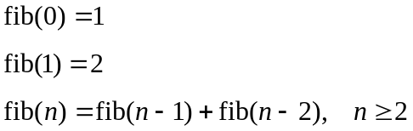
So, the first few Fibonacci numbers are: 1, 2, 3, 5, 8, 13, 21, 34, 55, 89, …

Using Fibonacci numbers as bases, the binary string 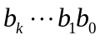 represents the number 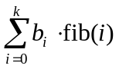.
For example, the binary string 100010 represents the number 15, since
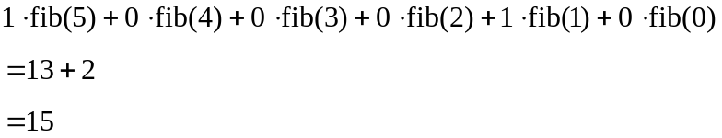
Observe that the binary string 11010 also represents the number 15, since 15 = 8+5+2.
To make the representation unique, larger Fibonacci number must always be used whenever possible (i.e. disallow two adjacent 1's). So, the number 15 is represented by 100010, rather than 11010.

Your problem is to find out the binary string that represents a given unsigned integer.

Input
The input consists of multiple datasets, followed by a line which contains only a single ‘.’ (period). Each dataset consists of a single line which contains an unsigned integer.

Output
For each input dataset, print the corresponding binary string representation using Fibonacci numbers as bases.

Sample Input
15
2971215072
4294967296
.
Sample Output for the Sample Input
100010
101010101010101010101010101010101010101010101
1010001000010101000101000100000001000100100100

All inputs are from stdin and outputs to stdout.

